g

PROGRAM TITLE
PROCUREMENT OF MATERIALS AND SERVICES
PROCESS TITLE
Service Contracting

- SCOPE

This policies and procedures manual establishes policies, systems, procedures and controls on service contracting. All duties and responsibilities stated in this manual are not exclusive to the personnel’s designated responsibilities in this process title.

- OBJECTIVES

- To ensure that proper authorization and procedures are observed when hiring services from contractors and other service providers.
- To ensure that services are obtained from suitable and approved service providers.
- To ensure that proper documentation is established in the service contracting process.
- To clearly define the duties and responsibilities of all personnel involved in this process title.

- PERSONNEL INVOLVED

  - User Department / Requisitioner

    - Requests services through the preparation of Materials / Services Procurement Requisition Form (MSPRF).
    - Prepares the following documents:
- Company Project Estimate (CPE) which contains the costs and technical requirements of the services
- Bid Evaluation Form (BEF)

    - Evaluates and examines the Contractor Bidding Documents (CBD) as forwarded by the Purchasing Department.
    - Reviews the Service Agreement (SA) before issuance for signature with the President and the contractor.

  - Human Resource Department

    - Periodically conducts and supervises the accreditation of contractors.
    - Evaluates and examines the CBD forwarded by the User Department.
    - Prepares the BEF which indicates the results of the assessment conducted on the contractor.
    - Reviews the Service Agreement (SA) before issuance for signature with the President and the contractor.

  - Purchasing Staff

    - Acknowledges the receipt of the MSPRF.
    - Prepares the following documents:
- Job Order (JO)
- Invitation to Bid
- Bid Tabulation
- Bidding Abstract
- Notice of Award
- Letter to Unsuccessful Bidders
- Notice of Failure of Bidding

    - Schedules the pre-bid conference with the prospect contractors.
    - Issues the CBD to the contractors and retrieves duly-filled out copies.
    - Prepares the initial draft of the Service Agreement to be reviewed the User Department and the HR Department.
    - Facilitates the signing of the Service Agreements.
    - Forwards duly filled out JO to appropriate signatories for approval.
    - Updates Project Monitoring System for hired services.

  - Canvasser

    - Performs canvassing of requested services from at least two (2) service providers.
    - Inputs the canvassed service providers into the ABAS for the preparation of the Canvass Report (CR).
    - Forwards duly filled-out CR to the appropriate signatories for approval.

  - Department Manager

    - Verifies/notes the following documents: (refer to section V.I.1, page 10)
- MSPRF
- CR
- JO

    - Approves the following documents: (refer to section V.I.1, page 10)
- MSPRF
- CR
- JO

  - Department Supervisor

    - Verifies/notes the following documents: (refer to section V.I.1, page 10)
- MSPRF
- CR

    - Recommends JO to appropriate approving officer. (refer to section V.I.1, page 10)

  - Vice President –

    - Approves the MSPRF, CR and JO. (refer to section V.I.1, page 10)
    - Reviews and signs the “Recommended for Approval” portion of the CPE

  - President / Senior Vice President

    - Approves the following documents:
- MSPRF, CR and JO (refer to section V.I.1, page 10)
- Bidding Abstract

    - Evaluates and signs the following documents:
- Contract Project Estimate
- Invitation to Bid
- Notice of Award
- Letter to Unsuccessful Bidders
- Notice of Failure of Bidding
- Service Agreement

- KEY TERMS

  - Contractors – This pertains to any person or entity engaged in a legitimate contracting or subcontracting arrangement services for a specific job or undertaking farmed out by the principal under a Service Agreement.

  - Emergency Requests – This pertains to level of priority of the request wherein the procurement of the service is deemed necessary to prevent loss of life, properties or stoppage of operations.

  - Service Agreement – This refers to the contract between the principal and the contractor containing the terms and conditions governing the performance or completion of a specific job or work being farmed out for a definite or predetermined period.

  - Principal – This pertains to any natural or juridical entity, whether an employer or not, who puts out or farms out a job or work to a contractor.

  - Responsive Bids – This is a bid or proposal that substantially complies with the invitation to bid or request for proposal and all prescribed procurement procedures and requirements.

- POLICIES

  - General Policies

    - Proper segregation of duties should be considered and implemented. As a minimum requirement, “approval”, “custody”, and “recording” functions should be segregated. Thus, management should make sure that an employee is not allowed to perform these functions all on his own.
    - Contracted services from service providers must adhere with the labor laws and standards set out by governmental bodies (i.e. Department of Labor and Employment, etc.).
    - Business forms shall be duly filled-out and signed by designated signatories. Any details/signatories which are not applicable must be duly indicated with “N/A”.
    - Alterations, if any, shall be duly countersigned.

  - Requisition for Services

    - A Materials/Services Procurement Requisition Form (MSPRF) shall be prepared for payment of services which are not covered by the Revolving Funds (RF).
    - The MSPRF shall be sequentially tagged with a control number upon receipt by the Purchasing Department.
    - The level of priority of the request must be indicated in the MSPRF. Description as to the level of priority follows:

Priority | Time to be Contracted from Date of Receipt of Request
Emergency | Within 24 hours
Regular - High | Within 3 working days
Regular - Medium | Within 7 working days
Regular - Low | Within 10 working days

    - Time frame for the processing of requisitions by Purchasing Department should not exceed at most ten (10) days from receipt of the said requisition unless such procurement of services is needed to undergo the bidding and accreditation procedures.
    - The following details must be duly indicated in the MSPRF:
- Project description
- Number of days the service is needed or the budget term of the service
- Number of services needed
- Technical expertise requirements, if any

  - Sourcing of Service Providers

    - A list of accredited contractors and service providers must be readily available to ensure that services can be easily canvassed.
    - Contractors and service providers shall be accredited at least once every three (3) years. The policies and procedures on the accreditation of the contractors and service providers shall be under the responsibility of the Human Resource (HR) Department. The accreditation shall be in coordination with the other departments for the examination of the technical aspects of the contractor’s operations.
    - New suppliers shall provide Supplier Accreditation Form and attach the necessary documents as stated in Requirement for Supplier Accreditation Form.
    - If necessary and practicable, visitation and ocular inspection of the service provider’s place of business may be conducted. Moreover, interviews and surveys may be provided to the contractor’s existing customers for third party confirmation of the contractor’s quality of performance.

  - Canvassing

    - Requested services shall be canvassed from at least two (2) service providers. The manner of canvassing shall be as follows:

Estimated Cost of Requested Services | Manner of Canvass
Below P10,000 | Verbal / Phone Canvass
P10,000 and above | Written Open Canvass

- Verbal / Phone Canvass
Canvass of prices may be done by taking quotations from service providers through the phone. However, written quotation shall still be secured. Moreover, the canvasser shall note down the phone numbers of the service providers in the Open Canvass for ready reference.

- Written Open Canvass
Written quotations shall be solicited by the Purchasing Department from the service providers through the Open Canvass.

    - Quotations shall be taken only from accredited service providers. If the requested services cannot be rendered by accredited service providers or if it’s too costly, quotations may then be secured from other sources but such shall be justified and coordinated with the User Department and HR Department.
    - Canvass shall be made for each services requested. However, for services which meets the requirements for bidding and contracting, no Canvass Report is required.
    - In cases when requested services are awarded to a service provider that does not offer the least possible cost, justification should be indicated in the canvass report.

  - Specifications

    - Specification requirements should be clearly indicated by the requesting department/personnel. For highly technical requirements, the requesting department/personnel shall be consulted as to what to be acquired. However, the Purchasing Department shall be responsible for the actual procurement of service based on an approved Job Order.
    - The Purchasing Staff shall stick to the user department’s specifications. If the services requested are not readily available to be handled by service providers or such quotation of the service is excessively expensive, the user department shall be informed outright. However, if the requests are very important for the Department to operate and not to incur delay in operations, such matter shall be brought to the attention of the Vice Presidents who shall make the final decision.

  - Job Order (JO)

    - When processing JO, Purchasing Staff must indicate whether the service provider is vatable, non-vatable, vat-exempt or zero-rated. By doing so, the Accounting and Finance Departments can determine the kind of payments needed for the processing of disbursements.
    - When processing JO, Purchasing Staff must indicate the appropriate expanded withholding tax applicable to the contractor. By doing so, the Accounting and Finance Departments can determine the kind of payments needed for the processing of disbursements.
    - One JO shall be prepared for every contractor or service agreement.
    - JOs shall be based on duly approved MSPRF, Canvass Report/Bidding Documents and Service Agreement.
    - JO must be pre-numbered and issued/printed sequentially.
    - Cancelled JO forms shall be properly marked “CANCELLED” and all copies shall be attached thereto. These shall be filed together with the Purchasing Department’s filing of JO.
    - Service providers shall be notified periodically regarding officers who are authorized to issue JO of specific commodity groups.
    - A JO shall still be prepared for procurement of services which undergo the bidding process.

  - Bidding, Accreditation and Service Agreements

    - The Invitation to Bid shall describe clearly and precisely the nature of the services for which the bids are to be invited, the technical standards/requirements which must be met, the place and period of service, the warranty and maintenance requirements, the method and criteria to be employed in the evaluation and comparison of bids, and other pertinent terms.
    - Prospective contractors must submit their Bidding Forms on or before the specified deadline for the submission of the bids. The Bidding Forms shall be sealed and contain the necessary documents for bidding. Bids which were submitted at least 30 minutes from the scheduled time of submission shall be considered disqualified.
    - Services shall undergo the bidding process when it agrees with at least one of the following requirements:
- Procurement of services with estimated amount of at least P100,000;
- Service engagements with duration of at least one year.

However, under certain circumstances, the Purchasing Manager may opt to enter into contract with service providers which did not the above criteria. However, justification must be made.

    - Services which meets the minimum requirements for bidding may not undergo the bidding process on the following instances:

- When the level of priority of the request is high and urgent, or when the procurement of the service is deemed necessary to prevent stoppage of operations. In this instance, the President or the Senior Vice President may, at his, discretion choose immediately from the existing list of accredited suppliers considering the best prices and quality. However, canvassing from at least three suppliers must still be performed and approved by the President.

- An accredited contractor with good historical records with the Company may be immediately appointed by the SVP or the President, as recommended by the HR and Purchasing Departments. However, the exemption to the policy must be duly supported with a written and signed document from the HR Department, Purchasing Department and the SVP / President.

    - The venue, time and date of the Pre-Bid Meeting shall be indicated in the Invitation to Bid which must be set at least three (3) working days before the set deadline for submission of the Bidding Forms and other necessary documents.
    - The prospect bidders shall bear the costs associated with the preparation and submission of their bid.
    - The Bidding Form and other pertinent documents submitted shall be written in English. However, if documents are written in another language, these must be accompanied by a duly translated document in English in which the latter shall govern.
    - Bidding Forms and other pertinent documents used in the bidding process shall be quoted in Philippine Peso. However, for bids which are dominated in foreign currency, these shall be converted into the Philippine Peso using the exchange rate prevailing on the day of the bid opening.
    - The following factors shall be considered in the accreditation of contractors:

- Resource Quality – The skill set of resources that will affect the delivery of the services. Evaluation must be conducted on how qualified and capable the workforce is and whether the professionals have previous experience of working similar projects. If necessary, going through the service provider’s portfolio may be done.

- Infrastructure – It must be taken into consideration that the acquired service providers has got the required infrastructural safeguards and back-ups that can prevent the business disruptions during severe downtime.

- Communication – The service provider must be able to communicate well with the Company’s personnel.

- Outsourcing Cost – Checking on the market prices before entering into a contract or engagement with the service provider. This will also help in determining whether the price quoted by the chosen service providers is justified.

- Compliance – Compliance by the service providers must be taken into consideration. Checking on historical records on the any issues with regulatory bodies may be conducted.

    - Determination of the Lowest Calculated Responsive Bid shall be determined using the following factors:
- The lowest calculated price as provided in the bidding; and
- The bid which complies with or is responsive to all the requirements of the Project Estimate.

    - The Service Agreement (SA) must be approved and reviewed by the user department, the Compliance Department and Human Resource Department.
    - The Service Agreements should include, at a minimum, the following details:
- The specific description of the job or work being contracted, including the term or duration;
- The place of work and terms and conditions governing the contracting arrangement, to include the agreed amount of the contracted job or work as well as the standard administrative fee of not less than ten percent (10%) of the total contract cost; and
- A provision on the issuance of the bond/s under Article 108 of the Labor Code renewable every year.

    - Evaluation of the bids shall be completed not later than thirty (30) calendar days from the date of the opening of the bids.
    - All clarifications and complaint shall be made in writing. Verbal complaint will not be entertained.
    - No information relating to the detailed evaluation of the bids and recommendations concerning awards shall be disclosed to persons outside of the Company before the announcement of the contract award to the successful bidder. After the award of contract, all unsuccessful bidders shall be informed individually in writing.

  - Monitoring

    - Analysis on cost trends shall be prepared by the Purchasing Department. They shall maintain the record and prepare reports on the following:
- List of all accredited service providers, specifying the services being rendered and this is to be classified as active or inactive
- Historical of quotations for services rendered
- List of alternative service providers and services rendered
- List of service providers classified per services being rendered
- Price Variance Reports
- Service Provider Performance Report, prepared annually, particularly for major service providers
- Complete service providers’ information (i.e. TIN, address, contact details, authorized representatives, etc.)

    - A monthly report shall be prepared by the Purchasing Department for all procurement of services that bypass standard procedures stated in this manual.
    - Inspection of work done shall be regularly conducted by the Concerned Department, Human Resource Department and Purchasing Department to assess the contractor’s compliance with the service agreement and with regulatory requirements. Thereafter, a final inspection shall be conducted by the aforesaid departments for the preparation of the Acceptance Reports or Certificate of Completion (for vessel and trucking repairs and maintenance). The Accounting Department shall be responsible for the overall cross-referencing of the documents forwarded for payment.
    - No payment shall be processed on Progress Billings or Statement of Account without duly signed Request for Payment and supporting Acceptance Report or Certificate of Completion and inspection reports.
    - The Acceptance Report shall be approved in accordance with the signing matrix as stated in Section V.I.1, page 10.

  - Signing Authorities

    - Forms signing authority matrix follows:

Form | Amount Range | Prepared by | Verified by | Approved by
Materials/Services Procurement Requisition Form (MSPRF) | P50,000 and below | Requisitioner | Department Supervisor | Department Manager
Materials/Services Procurement Requisition Form (MSPRF) | Above P50,000 to P150,000 | Requisitioner | Department Manager | Vice President
Materials/Services Procurement Requisition Form (MSPRF) | Above P150,000 | Requisitioner | Department Manager | SVP / President
Canvass Report (CR) | P50,000 and below | Canvasser | Department Supervisor | Department Manager
Canvass Report (CR) | Above P50,000 to P150,000 | Canvasser | Department Supervisor | Vice President
Canvass Report (CR) | Above P150,000 | Canvasser | Department Supervisor | SVP / President
Job Order (JO) | P50,000 and below | Purchasing Staff | Department Supervisor | Department Manager
Job Order (JO) | Above P50,000 to P150,000 | Purchasing Staff | Department Manager | Vice President
Job Order (JO) | Above P150,000 | Purchasing Staff | Department Manager | SVP / President

    - The Department Manager/Supervisor shall be construed as to whom the requisitioner is reporting to. However, managers of other departments may approve requests of other departments whenever the concerned department manager is not around provided that the concerned department manager shall communicate to the signing department manager prior to approval.
    - In the absence of the SVP or the President due to out of town trips or leave of absences, an authorized personal may approve/sign the MSPRF, CR and JO with prior written approval.
    - All CRs which amount is higher than P100,000 must pass through and countersigned by the VP prior to its submission to the SVP or President for approval.

- PROCEDURES

Requisition of Services

Step No. | Activity | Personnel  Involved | Business  Forms
1 | Prepares the Materials/Services Procurement Requisition Form (MSPRF) in two (2) copies to formally request for services.  Distribution of the MSPRF is as follows:  MSPRF 1 – Accounting Department  MSPRF 2 – Requisitioner | User Department / Requisitioner | Duly filled out MSPRF
2 | Forwards the MSPRF to the appropriate verifying officer. | User Department / Requisitioner | Duly filled out MSPRF
3 | Verifies the MSPRF. | Verifying Officer | Verified MSPRF
4 | Forwards the verified MSPRF to the appropriate approving officer. | User Department / Requisitioner | Verified MSPRF
5 | Approves the MSPRF. | Appropriate Approving Officer | Approved MSPRF
6 | Forwards duly approved MSPRF to Purchasing Department for processing of request.  Files one copy of the MSPRF numerically. | User Department / Requisitioner | Approved MSPRF

Canvassing of Service Providers

Step No. | Activity | Personnel  Involved | Business  Forms
1 | Canvass of prices/quotations is conducted from at least two (2) service provider.  After the canvass, a final choice is made as to where to avail the requested services. The service provider that offers the right requirements at the lowest costs possible shall be selected as the final choice. If the service provider with the lowest cost was not chosen, justification thereof should be indicated in the CR. | Canvasser
2 | Input the details of the canvassed prices/quotations in the ABAS for the preparation of the Canvass Report (CR) in two (2) copies.  Distribution of the CR is as follows:  CR 1 – Accounting Department  CR 2 – Purchasing Department | Canvasser | CR
3 | Forwards duly filled out Canvass Report to Purchasing Supervisor for verification. | Canvasser | Duly filled out CR
4 | Verifies CR. | Purchasing Supervisor | Verified CR
5 | Forwards duly verifies CR to the appropriate approving authority. | Canvasser | Verified CR
6 | Approves CR.  If the CR is not approved, Canvasser either re-canvass from other service providers or comply with the conditions set by the approving officer. | Refer to section V.I.1, page 10 | Approved CR
7 | Forwards duly approved CR to Purchasing Staff for the preparation of the Job Order (JO).  Files one copy of the CR numerically. | Canvasser | Duly approved CR.

Job Order Preparation

Step No. | Activity | Personnel  Involved | Business  Forms
1 | Receives duly approved CR or duly signed Service Agreement (SA) and prepares JO in duplicate copies.  The JO shall be distributed as follows:  JO 1 – Accounting Department  JO 2 – Purchasing Department | Purchasing Staff | Duly filled-out JO
2 | Forwards the JO to appropriate signatory for notification. | Purchasing Staff | Duly filled-out JO
3 | Receives duly filled-out JO and signs the “Noted by” portion. | Refer to section V.I.1, page 10 | Duly noted JO
4 | Receives duly noted JO and forwards the same to appropriate signatory for approval. | Purchasing Staff | Duly filled-out JO
5 | Approves the JO. | Refer to section V.I.1, page 10 | Duly approved JO
6 | Receives duly approved JO and updates Project Monitoring System. | Purchasing Staff | Duly approved JO
7 | Send the JO to the service provider for acknowledgement of services. | Purchasing Staff | Duly approved JO
8 | Receives duly acknowledged copy of the JO. | Purchasing Staff | Duly acknowledged JO
9 | File one copy of the JO and sends the second copy to the user department, together with the SA, if any. | Purchasing Staff | Duly acknowledged JO; duly signed SA

Implementation and Monitoring

Step No. | Activity | Personnel  Involved | Business  Forms
1 | Receives copy of duly acknowledged JO, together with signed copy of the SA, if any. | User Department | Duly acknowledged JO; duly signed SA
2 | Monitors the commencement of services by the contractor. | User Department
3 | Receives Progress Billing/Statement of Account from the contractor. | User Department
4 | Prepares the RFP to be signed by authorized signatories and forwards duly approved copy, with supporting documents, to the Accounting Department for payment processing.  Refer to process title “Check Requests and Disbursements”. | User Department | Duly approved RFP

Bidding and Accreditation Process

Step No. | Activity | Personnel  Involved | Business  Forms
1 | Requests User Department to prepare for bidding guidelines. | Purchasing Staff
2 | Prepares the Company Project Estimate (CPE) and signs the “Prepared by” portion. | User Department | Duly filled-out CPE
3 | Duly filled-out CPE shall be signed “Recommended for Approval” by the Vice President and forwarded to the SVP / President for approval.  If pertaining to vessel and trucking repairs, the duly approved Bill of Materials (BOM) shall be attached to the CPE, together with the Drydocking Schedule (vessel) or Motorpool Repairs and Maintenance Schedule Log (trucking). | Vice President/ SVP / President | Duly approved CPE
4 | Receives duly approved CPE. Seals CPE in an envelope. | Purchasing Staff | Duly approved CPE
5 | Proceeds to selection of prospective bidders and evaluates service contractors based on department’s selection criteria and fills-out Bid Evaluation Form (BEF). | User Department; Technical Expert; HR Department | Bid Evaluation Form
12 | Receives copies of BEF and prepares list of prospective service providers to send Invitation to Bid. | Purchasing Staff | Duly filled-out BEF
5 | Prepares and send Invitation to Bid to selected accredited contractors.  Invitation to Bid shall be duly signed by the Requesting Department’s Manager and approved by the President. | Purchasing Staff | Invitation to Bid
6 | Schedule pre-bid meetings with prospect contractors. | Purchasing Staff
7 | Facilitates commencement of the pre-bid meeting.  This is to be attended by a representative from the user department and the human resource department.  Representative from the Purchasing Department shall keep a record of the meeting held to be signed by the attendees of the meeting. | Purchasing Staff; User Department representative; HR Department representative | Minutes of the Meeting; Attendance Sheet
8 | Issues copies of Contract Bidding Documents (CBD) to the prospect contractors. These are to be filled-up and submitted together with other documents.  Upon submission, the CBD are to be sealed. | Purchasing Staff | Duly filled-out CBD
9 | Purchasing Department shall conduct the opening of the CBD.  This may be conducted in a separate date and venue but without the contractors. | Purchasing Staff | Duly filled-out CBD
10 | Summarizes the data from the CBD and prepares the Bidding Tabulation to compare the cost of the proposals with the Company estimate. | Bidding Committee | Duly filled-out CBD; Bidding Tabulation
11 | Summarizes evaluations and prepares Bidding Abstract for approval with the President. | Bidding Committee | Bidding Abstract
12 | Summarizes evaluations and prepares Bidding Abstract for approval with the President.  However, if no contractor was chosen due to justifiable reasons as determined by the Purchasing, HR and User Departments, a Notice of Failure of Bidding is sent to the contractors to schedule a second bidding.  Notice of Failure is to be signed by the Requesting Department and approved by the President. | Purchasing Department | Duly filled-out CBD; Bid Evaluation Form; Notice of Failure
13 | Prepares the Bidding Abstract and forwards the same, together with the duly filled-out CBD and Bid Evaluation Forms, to the President for evaluation.  The Bidding Abstract is to be signed “Reviewed by” the authorized personnel from each Department which participated in the evaluation of the prospect contractors | Purchasing Department | Bidding Abstract with attachments
14 | Evaluates the results of the bidding for approval. | President | Duly approved Bidding Results
15 | Receives duly approved Bidding Results and prepares the Notice of Award to be signed by the President and the representative from the following departments:  - Requesting Department  - HR Department  - Compliance Department  - Other departments which participated in the evaluation of bidders | Purchasing Staff | Notice of Award
16 | Sends Notice of Award to the chosen qualified contractor. The Notice is to be signed acknowledged by the chosen contractor upon receipt.  Letter to Unsuccessful Bidders shall be sent to the contractors which were not chosen.  The Letter to Unsuccessful Bidders shall be signed by the President and authorized personnel from the following:  - President  - Requesting Department  - HR Department  - Compliance Department  - Other departments which participated in the evaluation of bidders | Purchasing Staff | Notice of Award; Letter to Unsuccessful Bidders
17 | Prepares the Service Agreement (SA).  The preparation shall be subject to review by the user department, HR Department and Compliance Department. | Purchasing Staff | Service Agreement
18 | Facilitates signing of the SA and receives duly signed SA from the contractor. | Purchasing Staff | Duly signed SA

- FLOWCHARTS

  - Requisition of Services

  - Canvassing of Service Providers

  - Job Order (JO) Preparation

  - Implementation and Monitoring

  - Bidding and Accreditation Process

- BUSINESS FORMS

  - Materials/Services Procurement Requisition Form (MSPRF)

No. of Copies/color - 2
Explanation - this form is prepared to indicate request of services by the user departments which are not covered by disbursements through the Revolving Funds
Prepared by - Requisitioner
Verified by - Department Supervisor
Approved by - Department Manager
Distribution - MSPRF 1 - Initially to Purchasing Department then forwarded to Accounting Department (attached to the CkV)
MSPRF 2 - Requisitioner

  - Open Canvass

No. of Copies/color - 1
Explanation - this form is used to obtain quotations from service providers
Sent by - Canvasser
Data provided by - Service Provider
Distribution - Purchasing Department (file per service provider)

  - Canvass Report (CR)

No. of Copies/color - 2
Explanation - this form is used to indicate quotations for the requested services from at least two (2) service providers. The final choice of service provider is indicated in the CR
Prepared by - Canvasser
Verified by - Purchasing Supervisor
Approved by - Refer to section V.I.1, page 10
Distribution - CR 1 - Accounting Department (attached to the CkV)
CR 2 - Purchasing Department

  - Job Order (JO)

No. of Copies/color - 2
Explanation - This is used to order services from selected service providers. This will serve as the service provider’s authority to render the requested services to the Company
Prepared by - Purchasing Staff
Verified by - Purchasing Supervisor
Approved by - Refer to section V.I.1, page 10
Distribution - JO 1 - Service Provider
JO 2 - Accounting Department (attached to the CkV)
JO 3 - Purchasing Department

  - Acceptance Report

No. of Copies/color - 2
Explanation - This report is prepared to document and acknowledge that the service contracted with the contractor has been accomplished in compliance with the agreed service arrangement and regulatory requirements.
Prepared and
Accepted by - Concerned department

Conformed and
Checked by - Purchasing Department Manager
Human Resource Department Manager
Accounting Department Manager

Approved by - Refer to section V.I.1, page 10

Distribution - AR 1 - Purchasing Department
AR 2 - Accounting Department (attached to the APV)

  - Suppliers Database

No. of Copies/color - 1 (white)
Explanation - This is used to store the pertinent details of the Company’s suppliers for materials and services
Prepared by - Purchasing Staff
Distribution - Purchasing Department

  - Project Monitoring System

No. of Copies/color - 1
Explanation - This system is used to monitor the services acquired by the Company, either those which had undergone the bidding process or not
Prepared by - Purchasing Staff
Distribution - Purchasing Department

  - Cost Project Estimate (CPE)

No. of Copies/color - 1 (white)
Explanation - This is used to provide an estimation on the services are to be acquired which will undergo the bidding process. This is also used to determine the responsive bids which will serve as the basis in determining the reasonable price of the contract.
Prepared by - Requesting Department
Recommended for
Approval by - Vice President
Approved by - President
Distribution - Purchasing Department

  - Invitation to Bid

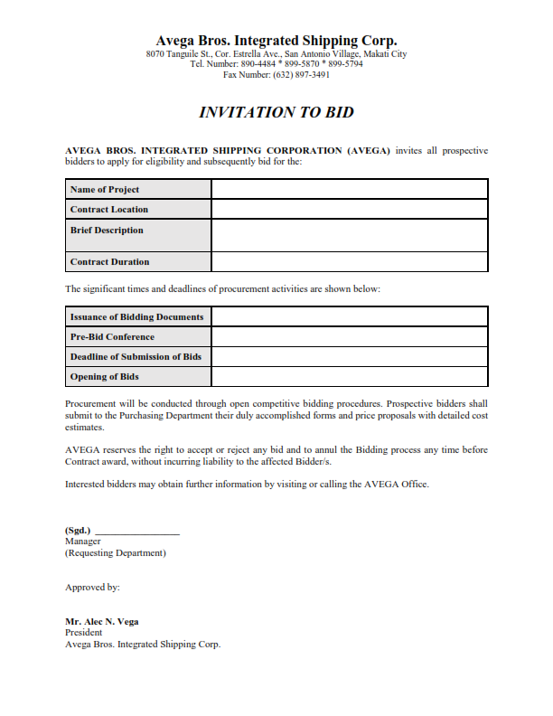

No. of Copies/color - Purchasing Department + No. of Bidders
Explanation - This is prepared and sent to invite prospect contractors to bid.
Signed by - Requesting Department’s Manager
Approved by - President
Distribution - Purchasing Department (file copy)

  - Contract Bidding Document (CBD)

No. of Copies/color - Purchasing Department + No. of Bidders
Explanation - This is issued to the prospect contractors after the pre-bid conference. This will indicate the prospect contractor’s budget and estimate on the proposed project or service.
Prepared by - Prospect Bidder / Contractor
Distribution - Purchasing Department (file copy)

  - Bid Tabulation

No. of Copies/color - 1 (white)
Explanation - This is prepared by the Purchasing Department to reflect the amount of estimated cost proposed by each prospect bidder. This is also used to determine the responsive bids as compared to the Company’s Project Estimate.
Prepared by - Purchasing Department
Distribution - Purchasing Department (file copy)

  - Bid Evaluation Form

No. of Copies/color - 1 (white)
Explanation - This is prepared to document the evaluation process conducted on every prospect bidder. The evaluation criteria may vary depending on the particular aspect which is being evaluated by the Evaluating Department.
Prepared by - Evaluating Department
Distribution - Purchasing Department (file copy)

  - Bidding Abstract

No. of Copies/color - 1 (white)
Explanation - This is prepared to summarize the evaluation process conducted. This form shall be used to document the ranking of prospect contractors for final evaluation of the President.
Prepared by - Purchasing Department
Reviewed by - Evaluating Departments
Approved by - President
Distribution - Purchasing Department (file copy)

  - Notice of Failure of Bidding

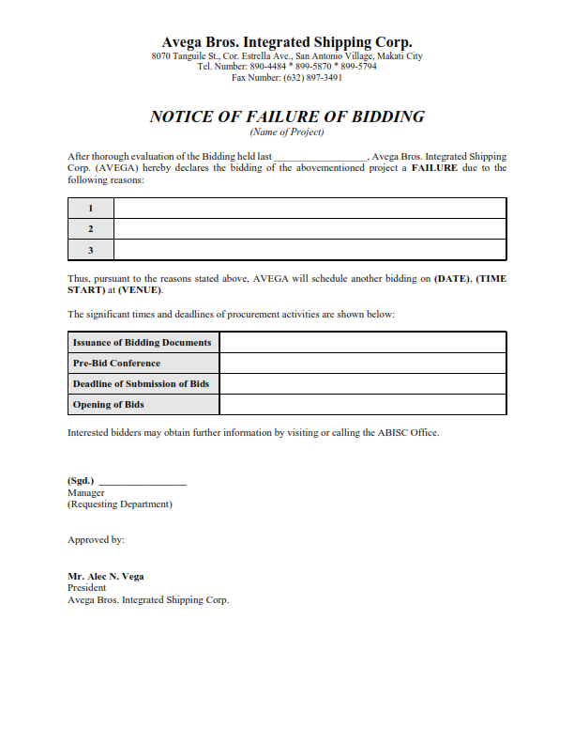

No. of Copies/color - 2 (white)
Explanation - This is prepared to formally notify bidders of failure of the bidding process and the details of another bidding.
Signed by - Requesting Department’s Manager
Approved by - President
Distribution - Notice 1 - Purchasing Department (file copy)
Notice 2 - Prospect contractor’s copy

  - Letter to Unsuccessful Bidders

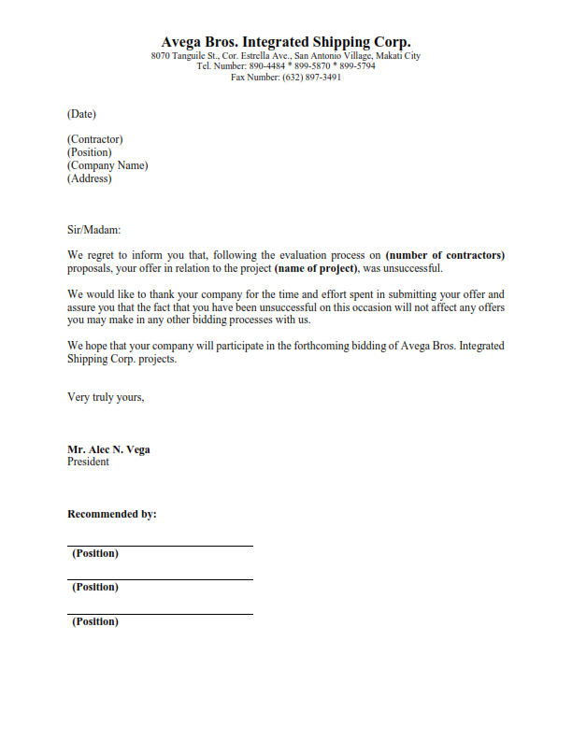

No. of Copies/color - 2 copies per bidder not awarded with the contract
Explanation - This is prepared to formally notify bidders which were not awarded with the contract.
Signed by - President
Recommended by - Requesting Department
Evaluating Department(s)
Distribution - Letter 1 - Purchasing Department (file copy)
Letter 2 - Prospect contractor’s copy

  - Notice of Award

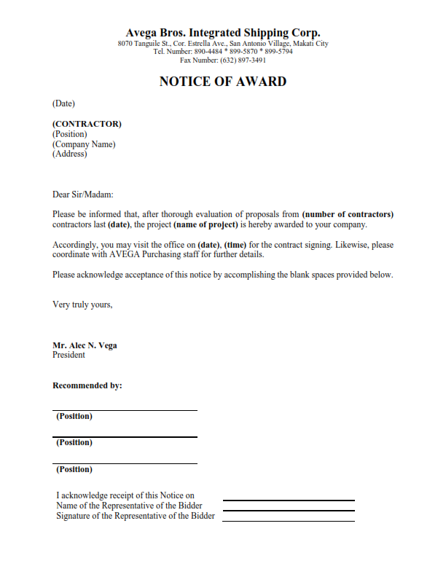

No. of Copies/color - 2
Explanation - This is prepared and sent to formally inform the bidder(s) awarded with the contract(s)
Signed by - President
Recommended by - Requesting Department
Evaluating Department(s)
Distribution - Letter 1 - Purchasing Department (file copy)
Letter 2 - Awarded bidder

  - Contractor Accreditation

No. of Copies/color - 2
Explanation - This is prepared to document the evaluation conducted on contractors.
Prepared by - Human Resource Staff
Recommended by - Human Resource Manager
Distribution - CA 1 - Human Resource Department (file copy)
CA 2 - Purchasing Department (to be attached to supplier’s profiles)

  - Supplier Accreditation Form

No. of Copies/color - 1
Explanation - This is used to store information of prospective suppliers for accreditation.
Checked by - Purchasing Staff
Verified by - Purchasing Supervisor
Approved by - Purchasing Manager
Distribution - Purchasing Department (filed together with other required documents for accreditation of supplier)

  - Requirements for Supplier Accreditation

No. of Copies/color - 1
Explanation - This is used to list all required documents to be submitted by prospective suppliers to be subjected to accreditation.
Distribution - Purchasing Department (filed together with the Supplier Accreditation Form)

- EFFECTIVITY

This Policies and Procedures Manual shall take effect upon approval and shall supersede any memorandum/SOP inconsistent with this Policies and Procedures Manual. Any changes to the manual shall comply with the policies and procedures indicated in the process title “Amendment of Manual”.

